**SPRINT-2**

|  |  |
| --- | --- |
| Date | 13 November 2022 |
| Project Name | Smart Farmer - IoT Enabled Smart Farming  Application |
| TEAM ID | PNT2022TMID15139 |

PROCEDURE:

* Install IDLE Python 3.9.8
* Open python idle and import wiotp.sdk.device , time , random libraries. Open Command prompt and install the packages for wiotp.sdk
* In myConfig function we have given all the credential details about user device type.
* Device client from wiotp.sdk.device library is passes myConfig function as parameter into config attribute and taken in variable named as client.
* At while loop statement the values of soil, temperature, humidity are taken and these values will be sent through the message to the user.
* Then the user will command the device to make motor on or off through the message.

Interfacing IBM Watson with IDLE Shell

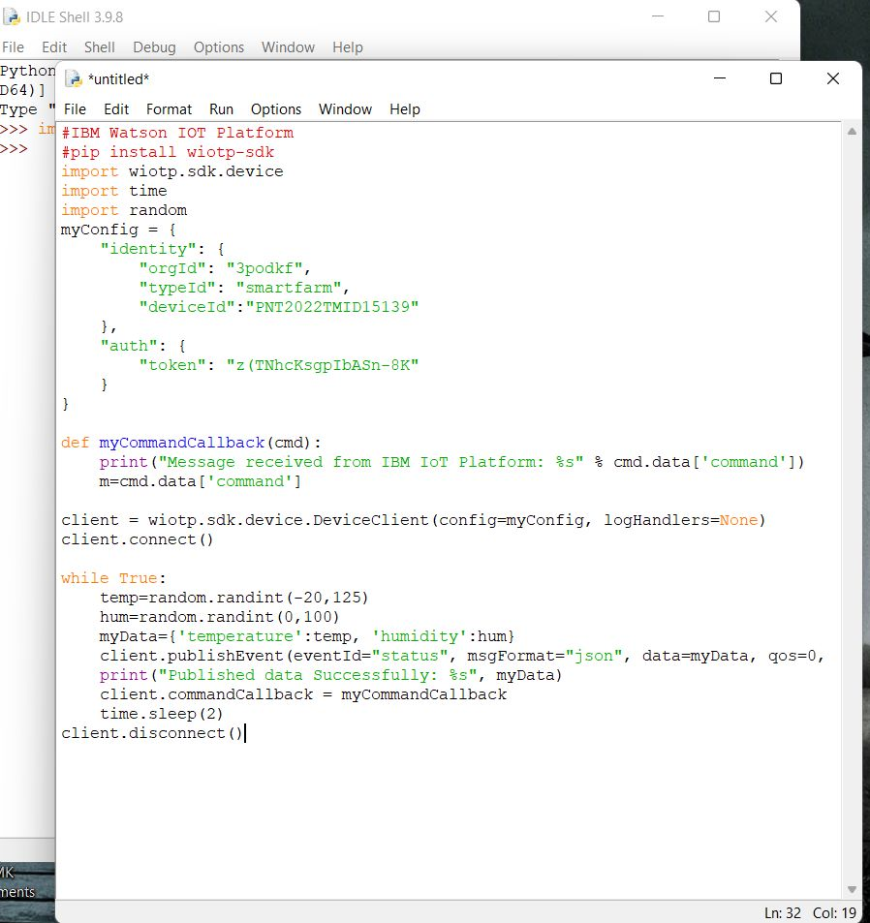

Installing the packages for Watson IoT

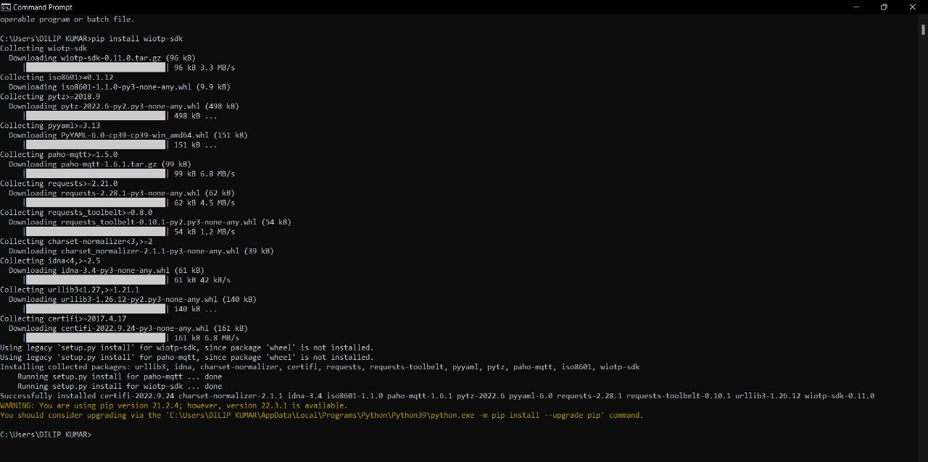

Message received from IoT Platform

